**DESCRIPTION**

You are hired as a cloud architect in a global media company. You have been asked to set up a WordPress instance to publish blogs for your company per the defined specifications.

**Background of the problem statement:**

Your organization publishes blogs and provides documentation services for other businesses and technologies. You have been asked to:

* Set up a live WordPress instance to publish blogs
* Set up a WordPress instance that can be used for development and testing purposes so that any work done on this instance will not impact the live blog
* Configure the WordPress instance for development and testing purposes, which will be available only for the business hours (9 AM–6 PM)
* Give access of the WordPress instance to the blogging team for development and testing purposes

**You must use the following:**

* Amazon CloudFormation
* AWS Auto Scaling
* Amazon Machine Images
* Amazon Identity and Access Management

**The following requirements should be met:**

* Ensure that the live WordPress instance has public read access from anywhere over the internet
* Ensure that you block the public access to the WordPress instance for development and testing purposes
* Ensure that only the blogging team has access to the WordPress instance for development and testing purposes
* Ensure that the WordPress instance for development and testing purposes gets shut down after 6 PM every day

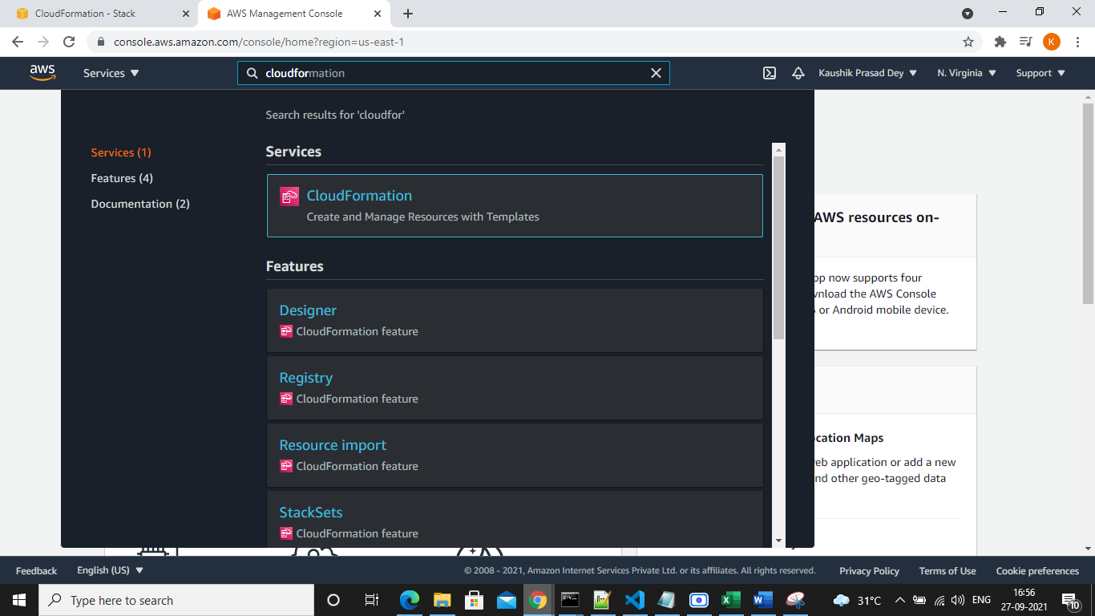

Mappings

Conditions

Parameters

Description

Resources

Outputs

View in Designer Tab

{

    "AWSTemplateFormatVersion": "2010-09-09",

    "Description": "This Template Creates a LAMP Stack for wordpress development.",

    "Parameters": {

        "KeyName": {

            "Description": "Key Pair name",

            "Type": "AWS::EC2::KeyPair::KeyName",

            "Default": "mykey"

        }

    },

    "Mappings": {

        "EC2RegionMap": {

            "ap-northeast-1": {"AmazonLinuxAMIHVMEBSBacked64bit": "ami-cbf90ecb"},

            "ap-south-1": {"AmazonLinuxAMIHVMEBSBacked64bit": "ami-f9daac96"},

            "ap-south": {"AmazonLinuxAMIHVMEBSBacked64bit": "ami-f9daac96"},

            "eu-central-1": {"AmazonLinuxAMIHVMEBSBacked64bit": "ami-a8221fb5"},

            "eu-west-1": {"AmazonLinuxAMIHVMEBSBacked64bit": "ami-a10897d6"},

            "sa-east-1": {"AmazonLinuxAMIHVMEBSBacked64bit": "ami-b52890a8"},

            "us-east-1": {"AmazonLinuxAMIHVMEBSBacked64bit": "ami-1ecae776"},

            "us-west-1": {"AmazonLinuxAMIHVMEBSBacked64bit": "ami-d114f295"},

            "us-west-2": {"AmazonLinuxAMIHVMEBSBacked64bit": "ami-e7527ed7"}

        }

    },

    "Resources": {

        "VPC": {

            "Type": "AWS::EC2::VPC",

            "Properties": {

                "CidrBlock": "172.31.0.0/16",

                "EnableDnsHostnames": "true"

            }

        },

        "InternetGateway": {

            "Type": "AWS::EC2::InternetGateway",

            "Properties": {

            }

        },

        "VPCGatewayAttachment": {

            "Type": "AWS::EC2::VPCGatewayAttachment",

            "Properties": {

                "VpcId": {"Ref": "VPC"},

                "InternetGatewayId": {"Ref": "InternetGateway"}

            }

        },

        "SubnetA": {

            "Type": "AWS::EC2::Subnet",

            "Properties": {

                "AvailabilityZone": {"Fn::Select": ["0", {"Fn::GetAZs": ""}]},

                "CidrBlock": "172.31.38.0/24",

                "VpcId": {"Ref": "VPC"}

            }

        },

        "SubnetB": {

            "Type": "AWS::EC2::Subnet",

            "Properties": {

                "AvailabilityZone": {"Fn::Select": ["1", {"Fn::GetAZs": ""}]},

                "CidrBlock": "172.31.37.0/24",

                "VpcId": {"Ref": "VPC"}

            }

        },

        "RouteTable": {

            "Type": "AWS::EC2::RouteTable",

            "Properties": {

                "VpcId": {"Ref": "VPC"}

            }

        },

        "RouteTableAssociationA": {

            "Type": "AWS::EC2::SubnetRouteTableAssociation",

            "Properties": {

                "SubnetId": {"Ref": "SubnetA"},

                "RouteTableId": {"Ref": "RouteTable"}

            }

        },

        "RouteTableAssociationB": {

            "Type": "AWS::EC2::SubnetRouteTableAssociation",

            "Properties": {

                "SubnetId": {"Ref": "SubnetB"},

                "RouteTableId": {"Ref": "RouteTable"}

            }

        },

        "RoutePublicNATToInternet": {

            "Type": "AWS::EC2::Route",

            "Properties": {

                "RouteTableId": {"Ref": "RouteTable"},

                "DestinationCidrBlock": "0.0.0.0/0",

                "GatewayId": {"Ref": "InternetGateway"}

            },

            "DependsOn": "VPCGatewayAttachment"

        },

        "NetworkAcl": {

            "Type": "AWS::EC2::NetworkAcl",

            "Properties": {

                "VpcId": {"Ref": "VPC"}

            }

        },

        "SubnetNetworkAclAssociationA": {

            "Type": "AWS::EC2::SubnetNetworkAclAssociation",

            "Properties": {

                "SubnetId": {"Ref": "SubnetA"},

                "NetworkAclId": {"Ref": "NetworkAcl"}

            }

        },

        "SubnetNetworkAclAssociationB": {

            "Type": "AWS::EC2::SubnetNetworkAclAssociation",

            "Properties": {

                "SubnetId": {"Ref": "SubnetB"},

                "NetworkAclId": {"Ref": "NetworkAcl"}

            }

        },

        "NetworkAclEntryIngress": {

            "Type": "AWS::EC2::NetworkAclEntry",

            "Properties": {

                "NetworkAclId": {"Ref": "NetworkAcl"},

                "RuleNumber": "100",

                "Protocol": "-1",

                "RuleAction": "allow",

                "Egress": "false",

                "CidrBlock": "0.0.0.0/0"

            }

        },

        "NetworkAclEntryEgress": {

            "Type": "AWS::EC2::NetworkAclEntry",

            "Properties": {

                "NetworkAclId": {"Ref": "NetworkAcl"},

                "RuleNumber": "100",

                "Protocol": "-1",

                "RuleAction": "allow",

                "Egress": "true",

                "CidrBlock": "0.0.0.0/0"

            }

        },

        "LoadBalancer": {

            "Type": "AWS::ElasticLoadBalancing::LoadBalancer",

            "Properties": {

                "Subnets": [{"Ref": "SubnetA"}, {"Ref": "SubnetB"}],

                "LoadBalancerName": "aws-simplearn-elb",

                "Listeners": [{

                    "InstancePort": "80",

                    "InstanceProtocol": "HTTP",

                    "LoadBalancerPort": "80",

                    "Protocol": "HTTP"

                }],

                "HealthCheck": {

                    "HealthyThreshold": "2",

                    "Interval": "5",

                    "Target": "TCP:80",

                    "Timeout": "3",

                    "UnhealthyThreshold": "2"

                },

                "SecurityGroups": [{"Ref": "LoadBalancerSecurityGroup"}],

                "Scheme": "internet-facing"

            },

            "DependsOn": "VPCGatewayAttachment"

        },

        "LoadBalancerSecurityGroup": {

            "Type": "AWS::EC2::SecurityGroup",

            "Properties": {

                "GroupDescription": "aws-simplearn-elb-sg",

                "VpcId": {"Ref": "VPC"},

                "SecurityGroupIngress": [{

                    "CidrIp": "0.0.0.0/0",

                    "FromPort": 80,

                    "IpProtocol": "tcp",

                    "ToPort": 80

                }]

            }

        },

        "WebServerSecurityGroup": {

            "Type": "AWS::EC2::SecurityGroup",

            "Properties": {

                "GroupDescription": "aws-simplearn-sg",

                "VpcId": {"Ref": "VPC"},

                "SecurityGroupIngress": [{

                    "CidrIp": "0.0.0.0/0",

                    "FromPort": 22,

                    "IpProtocol": "tcp",

                    "ToPort": 22

                }, {

                    "FromPort": 80,

                    "IpProtocol": "tcp",

                    "SourceSecurityGroupId": {"Ref": "LoadBalancerSecurityGroup"},

                    "ToPort": 80

                }]

            }

        },

        "DatabaseSecurityGroup": {

            "Type": "AWS::EC2::SecurityGroup",

            "Properties": {

                "GroupDescription": "aws-simplearn-db-sg",

                "VpcId": {"Ref": "VPC"},

                "SecurityGroupIngress": [{

                    "IpProtocol": "tcp",

                    "FromPort": "3306",

                    "ToPort": "3306",

                    "SourceSecurityGroupId": {"Ref": "WebServerSecurityGroup"}

                }]

            }

        },

        "Database": {

            "Type": "AWS::RDS::DBInstance",

            "Properties": {

                "AllocatedStorage": "5",

                "BackupRetentionPeriod": "0",

                "DBInstanceClass": "db.t2.micro",

                "DBInstanceIdentifier": "aws-simplearn-db",

                "DBName": "wordpress",

                "Engine": "MySQL",

                "MasterUsername": "wordpress",

                "MasterUserPassword": "wordpress",

                "VPCSecurityGroups": [{"Fn::GetAtt": ["DatabaseSecurityGroup", "GroupId"]}],

                "DBSubnetGroupName": {"Ref": "DBSubnetGroup"}

            },

            "DependsOn": "VPCGatewayAttachment"

        },

        "DBSubnetGroup" : {

            "Type" : "AWS::RDS::DBSubnetGroup",

            "Properties" : {

                "DBSubnetGroupDescription" : "DB subnet group",

                "SubnetIds": [{"Ref": "SubnetA"}, {"Ref": "SubnetB"}]

            }

        },

        "LaunchConfiguration": {

            "Type": "AWS::AutoScaling::LaunchConfiguration",

            "Metadata": {

                "AWS::CloudFormation::Init": {

                    "config": {

                        "packages": {

                            "yum": {

                                "php": [],

                                "php-mysql": [],

                                "mysql": [],

                                "httpd": []

                            }

                        },

                        "sources": {

                            "/var/www/html": "https://wordpress.org/wordpress-4.7.2.tar.gz"

                        },

                        "files": {

                            "/tmp/config": {

                                "content": {"Fn::Join": ["", [

                                    "#!/bin/bash -ex\n",

                                    "cp /var/www/html/wordpress/wp-config-sample.php /var/www/html/wordpress/wp-config.php\n",

                                    "sed -i \"s/'database_name_here'/'wordpress'/g\" wp-config.php\n",

                                    "sed -i \"s/'username_here'/'wordpress'/g\" wp-config.php\n",

                                    "sed -i \"s/'password_here'/'wordpress'/g\" wp-config.php\n",

                                    "sed -i \"s/'localhost'/'", {"Fn::GetAtt": ["Database", "Endpoint.Address"]}, "'/g\" wp-config.php\n",

                                    "chmod -R 777 wp-content/ \n"

                                ]]},

                                "mode": "000500",

                                "owner": "root",

                                "group": "root"

                            }

                        },

                        "commands": {

                            "01_config": {

                                "command": "/tmp/config",

                                "cwd": "/var/www/html/wordpress"

                            }

                        },

                        "services": {

                            "sysvinit": {

                                "httpd": {

                                    "enabled": "true",

                                    "ensureRunning": "true"

                                }

                            }

                        }

                    }

                }

            },

            "Properties": {

                "EbsOptimized": false,

                "ImageId": {"Fn::FindInMap": ["EC2RegionMap", {"Ref": "AWS::Region"}, "AmazonLinuxAMIHVMEBSBacked64bit"]},

                "InstanceType": "t2.micro",

                "SecurityGroups": [{"Ref": "WebServerSecurityGroup"}],

                "KeyName": {"Ref": "KeyName"},

                "AssociatePublicIpAddress": true,

                "UserData": {"Fn::Base64": {"Fn::Join": ["", [

                    "#!/bin/bash -ex\n",

                    "yum update -y aws-cfn-bootstrap\n",

                    "/opt/aws/bin/cfn-init -v --stack ", {"Ref": "AWS::StackName"}, " --resource LaunchConfiguration --region ", {"Ref": "AWS::Region"}, "\n",

                    "/opt/aws/bin/cfn-signal -e $? --stack ", {"Ref": "AWS::StackName"}, " --resource AutoScalingGroup --region ", {"Ref": "AWS::Region"}, "\n"

                ]]}}

            }

        },

        "AutoScalingGroup": {

            "Type": "AWS::AutoScaling::AutoScalingGroup",

            "Properties": {

                "LoadBalancerNames": [{"Ref": "LoadBalancer"}],

                "LaunchConfigurationName": {"Ref": "LaunchConfiguration"},

                "MinSize": "2",

                "MaxSize": "2",

                "DesiredCapacity": "2",

                "VPCZoneIdentifier": [{"Ref": "SubnetA"}, {"Ref": "SubnetB"}]

            },

            "CreationPolicy": {

                "ResourceSignal": {

                    "Timeout": "PT10M"

                }

            },

            "DependsOn": "VPCGatewayAttachment"

        }

    },

    "Outputs": {

        "URL": {

            "Value": {"Fn::Join": ["", ["http://", {"Fn::GetAtt": ["LoadBalancer", "DNSName"]}, "/wordpress"]]},

            "Description": "Wordpress URL"

        }

    }

}

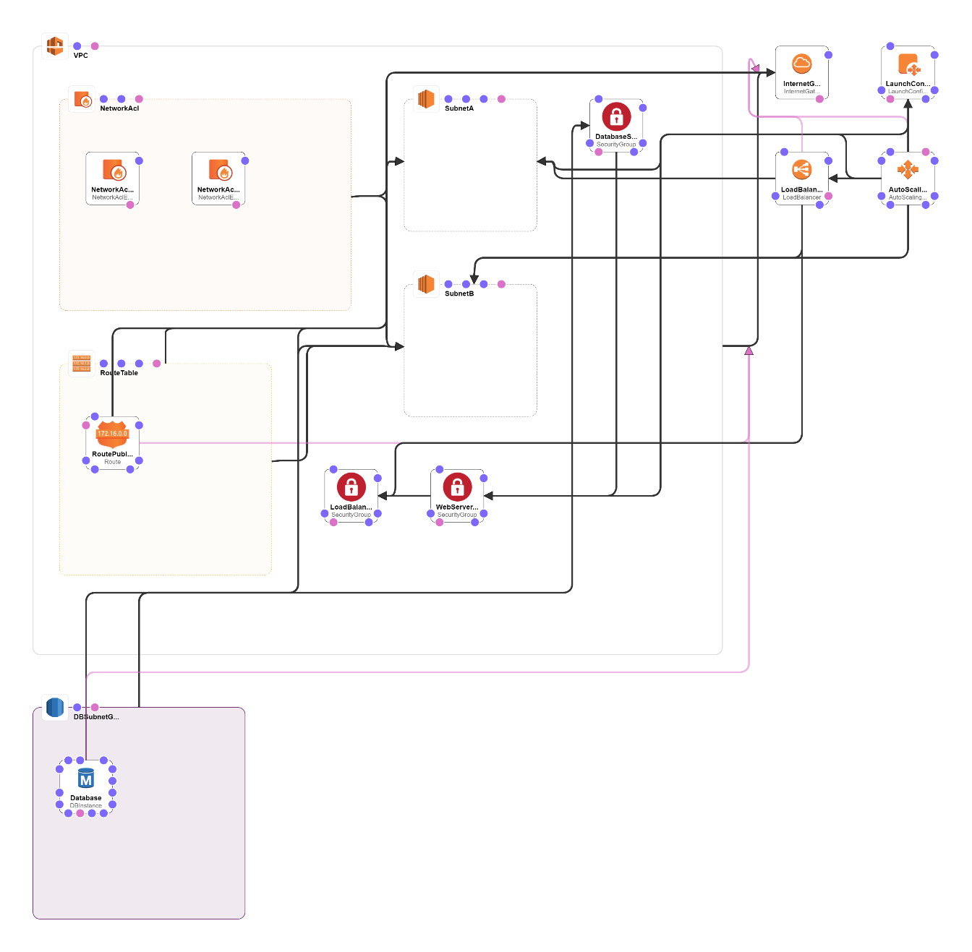

# **Architecture:**

wget <https://s3.amazonaws.com/solutions-reference/aws-instance-scheduler/latest/scheduler-cli.zip>

unzip scheduler-cli.zip

cd scheduler-cli

python setup.py install

scheduler-cli create-period --stack Ec2instanceScheduler --region us-east-1 --name firstdayofmonth --begintime 09:00 --endtime 06:00 --monthdays 1

scheduler-cli create-schedule --stack Ec2instanceScheduler --name dayone --region us-east-1 --periods firstdayofmonth --timezone UTC

